**LED AND LIGHTING**

**1. Led lightss**

* An LED, also known as an LED bulb, is an electric light used in lighting devices that produces light using one or more light-emitting diodes.
* Civil lighting: LED lights are strongly applied in the field of modern and classic interior decoration, exterior decoration, miniatures, gardens, ...

Industrial lighting: Because of its high cost, although they clearly understand the priority features of LED art lights, only a small part of foreign business owners who are capable of returning to the main site choose the solution. artistic LED lighting for the manufacturers of their own businesses.

* List of products:

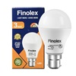**No.1: Finolex 3W LED Bulbs**

List Price: Rs. 130

Selling Price: Rs. 75

You Save: Rs. 55.00

**Special Feature:**

* Long life - almost zero maintenane cost.
* Environment friendly - zero mercury used.
* Ultra efficient & energy saver.
* Flicker free operations.
* Lasts upto 25,000 burning hours
* Beam angle 120D
* Centre beam intensity 60Cd (225 Lm in a cone 90D)

**PRODUCT SPECIFICATION**

|  |  |
| --- | --- |
| **Brand** | Finolex |
| **Product Category** | LED Bulbs |
| **Power** | 3 W |
| **Voltage** | 240 V |
| **Colour Temperature** | 6500 K |
| **Lumen Output** | 300lm |
| **Nominal Frequency** | 50 Hz |
| **Bulb Base** | B-22 |
| **Length** | 96mm |
| **Rated Life** | 25,000 Hrs |
| **Energy Saving** | Yes |
| **Suitable For** | Modern architechture lighting. Suitable for Electronic swithes |
| **Package Contents** | 1 LED Bulb |
| **Warranty** | 1 Year (against manufacturing defects) |

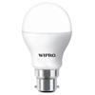No2. **Wipro Tejas 7W LED Bulbs**

Selling Price: Rs. 90

You Save: Rs. 70.00 (43.75%)

(Price Inclusive of GST)

**Special Features:**

* Saves 85% energy with life up to 15 years
* Robust driver with wide voltage range 100-240VAC and inbuilt protection
* Light weight and decorative look fits in CFL sockets

Wipro Garnet LED Bulb 7W saves 85% energy and provides light distribution in all directions, through its innovatively designed optics.

**PRODUCT SPECIFICATION**

|  |  |
| --- | --- |
| **Brand** | Wipro |
| **Product Category** | LED Bulbs |
| **Power** | 7 W |
| **Voltage** | 240 V |
| **Colour Temperature** | 6500 K |
| **Lumen Output** | 600 lm |
| **Bulb Base** | B-22 |
| **Beam Angle(Degree)** | 240° |
| **Rated Life** | 15 years |
| **Light Source** | LED |
| **Energy Saving** | Yes |
| **Suitable For** | Drawing room, Kitchen, Study room, Office, Corridors, Parking areas |
| **Package Contents** | 1 Bulb |
| **Certification** | IS 16102-1 |
| **Warranty** | 1 Year (against manufacturing defects) |

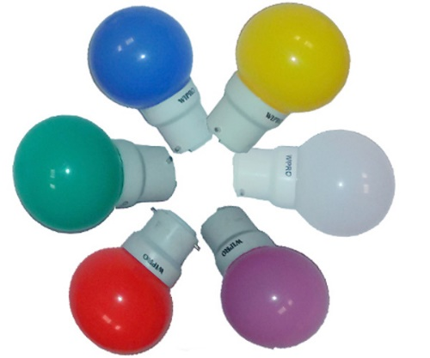No3. **Wipro 0.5W LED Bulbs (6 Pcs)**

List Price: Rs. 100

Selling Price: Rs. 230

You Save: Rs. -130.00 (-130.00%)

(Price Inclusive of GST)

**Special Features:**

* Available in Blue, Green, Orange, Pink, Red, and Yellow
* Green energy-No lead or mercury, Colorful light effect
* Easy to install-Standard Medium Base (E26)
* PERFECT FIT –This color bulbs use in table lamps, floor lamps, sconces, ceiling fixtures,porch and outdoors when protected from the weather
* These colored light bulbs ideal for Christmas, Halloween, parties and events, great Incandescent E26 Medium Base A19/G45 replacement bulb

**PRODUCT SPECIFICATION**

|  |  |
| --- | --- |
| **Brand** | Wipro |
| **Product Category** | LED Bulbs |
| **Power** | 0.5 W |
| **Voltage** | 240 V |
| **Colour Temperature** | 6500 K / 4000 K / 3000 K |
| **Lumen Output** | 56 lm |
| **Bulb Base** | B-22 |
| **Rated Life** | 25,000 Hrs |
| **Light Source** | LED |
| **Energy Saving** | Yes |
| **Material** | Aluminium |
| **Suitable For** | Decoration Night Lamp |
| **Package Contents** | 6 Bulb |
| **Certification** | FCC |
| **Warranty** | 2 Years (against manufacturing defects) |

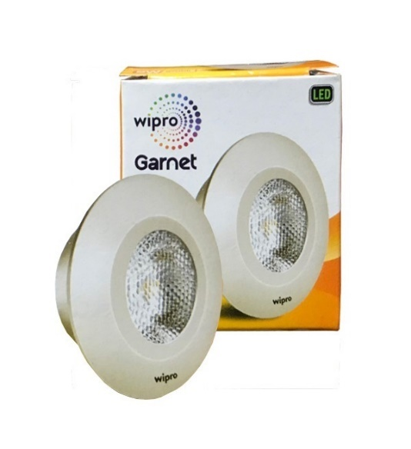No4. **Wipro Garnet 2W LED Spotlight**

Selling Price: Rs. 130

You Save: Rs. 95.00 (42.22%)

(Price Inclusive of GST)

**Special Features:**

* MULTIPLE USES- SunLake’s flood light bulbs are wet-rated specifically for outdoor applications but can also be used indoors especially for illuminating artwork, sculptures, and architectural highlight. Great bright spotlights for wall washing
* ELECTRICITY SAVER- Comparable incandescent spotlight bulbs use 75 watts and lose 95% to heat. SunLake led outdoor flood light bulbs 75 watt-equivalent use 10 watts to produce the same amount of light with nearly no energy lost to heat at all

**PRODUCT SPECIFICATION**

|  |  |
| --- | --- |
| **Brand** | Wipro |
| **Product Category** | LED Spotlight |
| **Model Name** | Garnet |
| **Power** | 2 W |
| **Colour Temperature** | 2700 K |
| **Voltage** | 240 V |
| **Shape** | Round Casing |
| **Light Source** | LED |
| **Energy Saving** | Yes |
| **Package Contents** | 1 LED Spotlight |
| **Suitable For** | Drawing room, Kitchen, Study room, Office, Corridors, Parking areas |
| **Certification** | FCC |

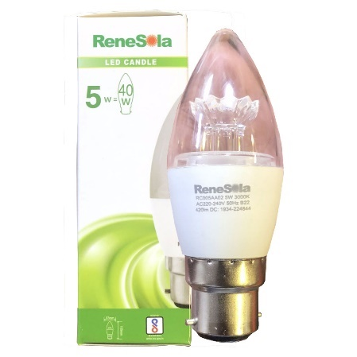No5. **Renesola 5W LED Candle Lamp**

Selling Price: Rs. 150

You Save: Rs. 245.00 (62.03%)

(Price Inclusive of GST)

**Special Features:**

* Safty & Usage:C7 replacement bulbs - 360 degrees beam angle,with overload protection,Short circuit protection and over temperature protection.This 0.5 watt edison lights are prefer using for Salt Lamp, living rooms, dining rooms, bedrooms, bathrooms, refrigerators,kitchens and recreation rooms,perfectly make a warm atmosphere!
* Energy Saving & Long Life Span:High brightness and low power consumption,the led night light bulbs provide over 25,000 hours life span.This E12 Edison LED blubs replace 5W Incandescent Bulb by 0.5W Filament 2200K LED Bulb.Up to 92% energy saving and reducing re-lamp replacement frequency, Saving Money on energy.

**PRODUCT SPECIFICATION**

|  |  |
| --- | --- |
| **Brand** | Renesola |
| **Product Category** | LED Bulbs |
| **Power** | 5 W |
| **Colour Temperature** | 3000 K |
| **Bulb Base** | B-22 |
| **Package Contents** | 1 LED Lamp |
| **Suitable For** | Offices, Reception areas, Banks, Lecture halls, Drawing room, Kitchen, Study room, Office, Corridors, Parking areas |
| **Light Source** | LED |
| **Lumen Output** | 440 lm |
| **Warranty** | 1 Year (against manufacturing defects) |

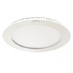

No6. **Compact 6W (L-97) Round LED Panel**

Selling Price: Rs. 394

You Save: Rs. 131.00 (24.95%)

(Price Inclusive of GST)

**Special Features:**

* HIGH PERFORMANCE - The edge-lit LEDs in the round flat panel light are integrated, so no bulbs needed. 24W, 2400 Lumens is perfect for bedroom, kitchen, closet, bathroom, living room, garage, basement, ect.
* Drop ceiling, flush mount lighting installation - Edge-lit and ultra slim design(less than 1 in.) made it perfect for any low ceiling area without any glare. Slide & lock mounting bracket enables a easy and safety installation. Rated for damp location.
* COLOR CHANGING CCT- With our selectable color switch, you can preset your preferred light color temperature: soft white, bright white or daylight (3000K/4000K/5000K).
* DIMMABLE: 5%-100% dimming range, the flat panel led light is compatible with most household triac LED dimmers for smooth and flicker-free operation.

**PRODUCT SPECIFICATION**

|  |  |
| --- | --- |
| **Brand** | Compact |
| **Product Category** | LED Panels |
| **Lumen Output** | CW = 450 lm / NW = 425 lm / WW = 410 lm |
| **Model Name** | L-97 |
| **Power** | 6 W |
| **Colour Temperature** | 6500 K / 4000 K / 3000 K |
| **Voltage** | 240 V |
| **CRI** | 80 |
| **Shape** | Round Casing |
| **Beam Angle(Degree)** | 135° |
| **Light Source** | LED |
| **Energy Saving** | Yes |
| **Power Supply** | Electronic Driver |
| **Package Contents** | 1 Panel Light |
| **Suitable For** | Indoor, Office, Retail |
| **Warranty** | 1 Year (against manufacturing defects) |

**2. Compact Fluorescent Lamp (CFL)**

* A compact fluorescent lamp (CFL) also called compact fluorescent light, energy-saving lightand campact fluorescent tube, is a fluorescent lamp designed to replace an incandescent light bulb; some types fit into light fixtures designed for incandescent bulbs. The lamps use a tube which is curved or folded to fit into the space of an incandescent bulb, and a compact electronic ballast in the base of the lamp.
* The principle of operation remains the same as in other fluorescent lighting: electrons that are bound to mercury atoms are excited to states where they will radiate ultraviolet light as they return to a lower energy level; this emitted ultraviolet light is converted into visible light as it strikes the fluorescent coating, and into heat when absorbed by other materials such as glass.
* 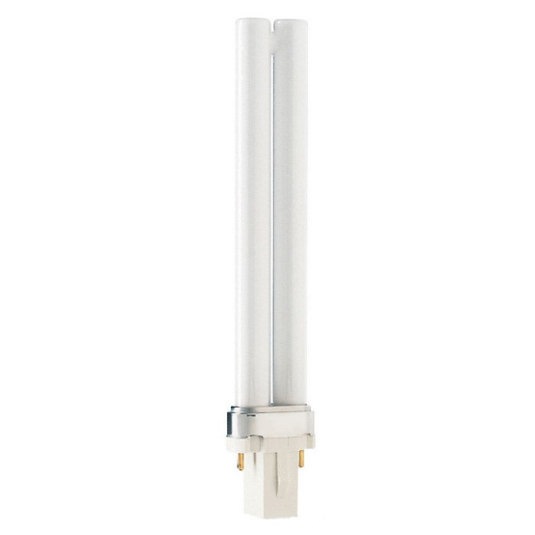List of products:

**No1. Philips 9W 2Pin PLS CFL**

Selling Price: Rs. 90

* This Philips 13-watt Soft White Fluorescent light bulb brightens laundry rooms, bathrooms, kitchens, and offices.
* Versatile for multiple applications, this 2700-Kelvin Fluorescent bulb is suitable for indoor, commercial, and residential use and may be used in surface-mounted down light fixtures and recessed cans.
* Features a 2-Pin GX23 base. Low-mercury design creates a smaller environmental footprint.
* Philips reuses as much glass and packaging material as possible, reducing environmental impact. Lamp life of 10,000 hours.
* This product ships as a single bulb and comes with a 1-year warranty.

**PRODUCT SPECIFICATION**

|  |  |
| --- | --- |
| **Brand** | Philips |
| **Product Category** | PLC , PLL & PLS CFLs |
| **Model Name** | PLS CFL |
| **Power** | 9 W |
| **Colour Temperature** | 6000 K / 3000 K |
| **Bulb Base** | G-23 (2 Pin) |
| **Package Contents** | 1 CFL |
| **Lumen Output** | 600 lm |

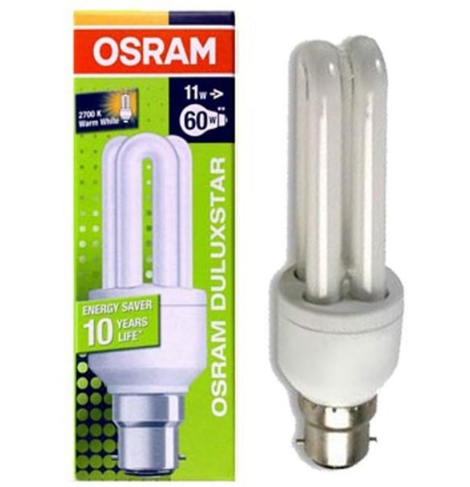**No2. Osram 11W B-22 2U Type CFL**

Selling Price: Rs. 131

* Small designer luminaires
* Wherever compact and efficient lamps are needed
* High-quality domestic and professional environments
* General illumination
* Wherever light is required quickly
* Outdoor use in enclosed and ventilated luminaires only.

**PRODUCT SPECIFICATION**

|  |  |
| --- | --- |
| **Brand** | Osram |
| **Product Category** | Domestic 5W-23W |
| **Power** | 11 W |
| **Bulb Base** | B-22 |
| **Package Contents** | 1 CFL |
| **Warranty** | No Guarantee/No Warranty/No Exchange (As the product manufacturer doesn't offer it) |

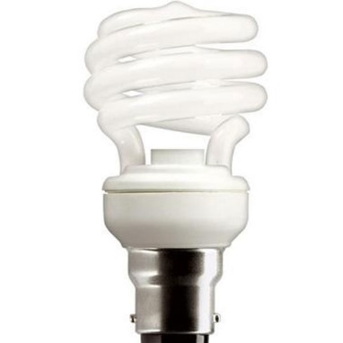No3. **Osram 5W B-22 T2 Mini Spiral CFL**

Selling Price: Rs. 230

* Among the smallest energy-saving lamps
* Extremely small dimensions
* Very compact shape with high efficiency
* Extremely fast lumen ramp-up thanks to Quick Light Technology
* Up to 80% less energy consumption compared with ordinary light bulbs
* Three year guarantee

**PRODUCT SPECIFICATION**

|  |  |
| --- | --- |
| **Brand** | Osram |
| **Product Category** | Domestic 5W-23W |
| **Power** | 5 W |
| **Bulb Base** | B-22 |
| **Package Contents** | 1 CFL |
| **Warranty** | No Guarantee/No Warranty/No Exchange (As the product manufacturer doesn't offer it) |

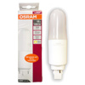No4. **Osram 12W 2 Pin G-24d PL LED Bulb**

Selling Price: Rs. 290

You Save: Rs. 370.00 (56.06%)

(Price Inclusive of GST)

Osram 12W LED PLC Lamp, that fits in exactly the same downlighter/connector as an 26W PLC CFL Lamp. It offers the same level of light output but uses only half the power of the PL lamps. This PLC LED Lamp life span is 15,000 hours, and comes with 2 years replacement warranty.

If the downlighter uses magnetic/copper ballasts, then just replace the PLC Lamp with the LED and no wiring change is required. For Downlighters with electronic ballasts, the ballast wiring needs to be cut, so that the LED Lamp can be powered directly by 220V AC Mains.

**PRODUCT SPECIFICATION**

|  |  |
| --- | --- |
| **Brand** | Osram |
| **Product Category** | PL LEDs |
| **Lumen Output** | 1250 lm |
| **Power** | 12 W |
| **Bulb Base** | G-24d (2 Pin) |
| **Energy Saving** | Yes |
| **Package Contents** | 1 LED Bulb |
| **Warranty** | 2 Years (against manufacturing defects) |

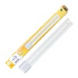**No5. Wipro 18W 4Pin LED PLL**

Selling Price: Rs. 395

You Save: Rs. 305.00 (43.57%)

(Price Inclusive of GST)

Sleek profile with consistent performance, High energy saving resulting in significant reduction in operating cost, Maintenance free and long service life and easy installation.  
Its an ideal replacement for Philips Master PL-L 36w/865/4P CFL and Osram DULUX L 36 W/865 2G11 CFL.

**PRODUCT SPECIFICATION**

|  |  |
| --- | --- |
| **Brand** | Wipro |
| **Product Category** | PL LEDs |
| **Power** | 18 W |
| **Colour Temperature** | 6500 K |
| **Bulb Base** | 2G11 (4 Pin) |
| **Package Contents** | 1 LED PLL |
| **Suitable For** | Offices, Reception areas, Banks, Lecture halls, Drawing room, Kitchen, Study room, Office, Corridors, Parking areas |
| **Light Source** | LED |
| **Lumen Output** | 100 lm / Watt |
| **Warranty** | 1 Year (against manufacturing defects) |